Insert logo here
Family Tree
So many of our personal habits are initially formed through family dynamics and behavior. As a result, it’s easy to adopt — and then pass along — habits that have unrecognized impacts on our children’s long-term health and wellness.
Traditions are not bad in and of themselves. But it is important to understand the impact of choices such as:
- what we eat (the nutritional makeup of our food)
- how much we eat
- how often we eat
- how much we exercise
- how we manage our stress
This month’s Kit is designed to help raise awareness about how family dynamics and health histories can be understood in the context of future wellness, especially for children.
How To Use
On the back of this page, you will find a tree illustration. It’s a bit like a visual family health history, and it can help you observe both the desirable and undesirable health outcomes that may run in your family.
- The roots represent the norms you grew up with and perhaps are passing along to your children. This could include things like whether or not you eat meals together regularly, the amount of sugar/salt/fat in your diet, how much time you spend snacking in front of the TV, your level of nutritional IQ, and much more.
- The trunk represents some of the “family traits” that we might credit our genes for, such as being overweight, having high blood pressure, being diabetic, etc.
- The branches represent the members of the family who exhibit those traits.
To complete the tree:
- Start with the branches. List yourself, your spouse, all parents, grandparents…even aunts and uncles! Name each one and list chronic health issues that person may exhibit (diabetes, high blood pressure, overweight, knee problems, etc.).
- Look for the things that are repeated among multiple “branches” of your tree and write them by the trunk. These are your family’s typical health outcomes.
- Then talk to your child’s pediatrician about what you see. Which of these conditions are related to habits or traditions that might run in your family? How can you create different health outcomes for your little leaves by understanding the causes of these conditions?
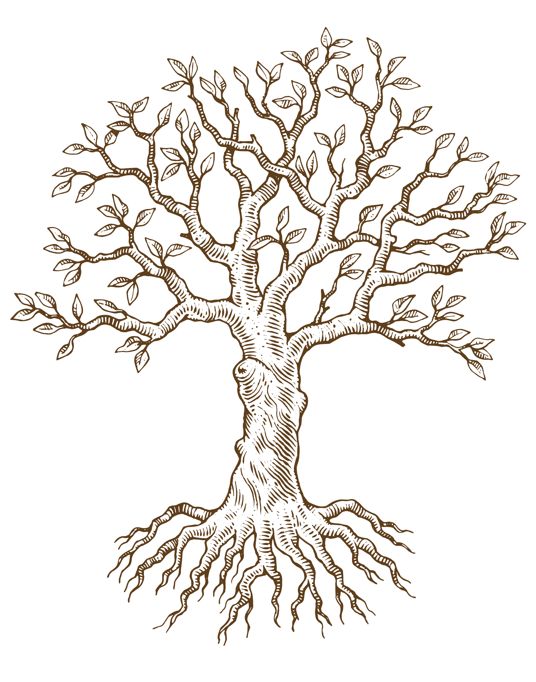
Family Tree

Insert logo here

Family Name: ___________________________

