
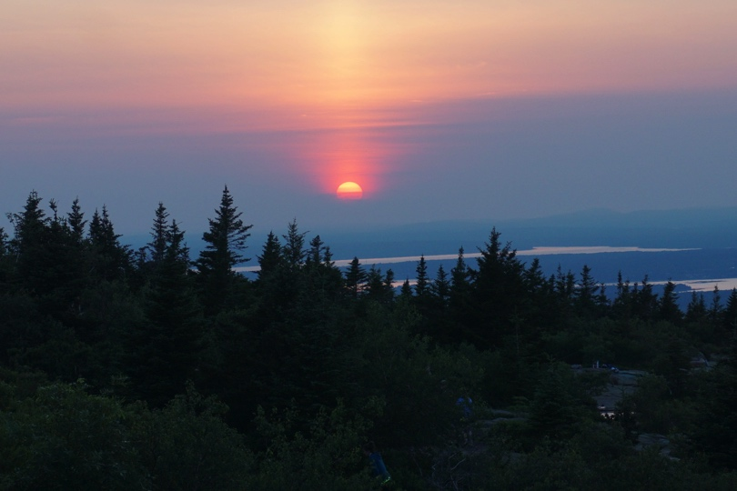
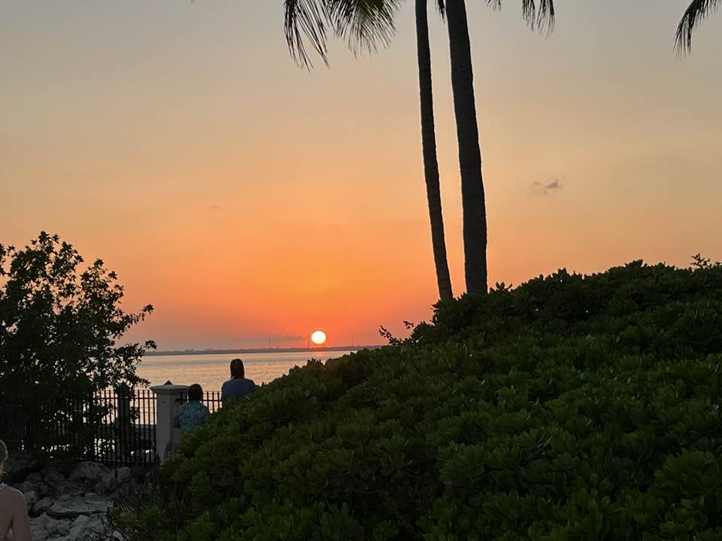

We all love to admire gorgeous sunrise and sunset photos. Do you know why?

The 'wow' factor associated with these encounters can unlock small but significant bumps in feelings of beauty and awe. That can, in turn, have positive impacts on mental wellbeing.

Let’s all share the sun this month and help each other feel great!

How to Play
Go for a walk at sunrise or sunset this month. Snap a photo and submit it to Human Resources. Be sure to include the date, time (sunrise or sunset) and where you took the photo.

You can take photos anywhere…your home, the beach, or on a trip. It’s fun to see local beauty but it’s also great to share spectacular scenes from other places.

Submit your photo from September 1-September 30. Winners will be announced on October 1.
Share the Sun!
Insert Your Logo Here

